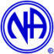

Cullowhee Connection 27th Annual Campout
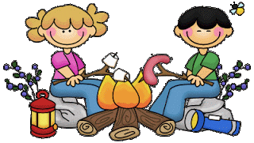

FRIDAY & SATURDAY, JULY 17 & 18, 2020

RALPH J. ANDREWS CAMPGROUND, GLENVILLE, NC
814 Ralph J. Andrews Dr., Glenville, NC
rjacampground@jacksonnc.org 828.743.3923
Please tell them that you are with the NA Group when you call to make reservations.

Please be aware of, and respectful of the campground rules and regulations!

Friday, July 17- 7:00pm-Low-Country Boil Friday night
9:00pm-Opening NA meeting around the fire

Saturday, July 18- 9:00am-Good morning NA meeting
2:00pm-NA meeting (on the water, so bring your floaties)
5:00pm-burgers and hotdogs at the pavilion area
(Cullowhee Connection will provide main course and beverages)
Please Bring Side Dishes and Desserts to Share

5:00pm-speakers Brandon from Waynesville and Belinda T. from W.V.

Sunday, July 19- 9:00am-wrap up NA meeting

Bring chairs, camping gear, fire wood, water toys, friends and family, and food/beverages for your group for the weekend.

For more information--Annette P. 828.506.5047, Gary D. 408.568.2746, Kathy 828.226.4415 or Renee C. 828.507.0799

